**Python-Coding Challenge**

**Submitted By-**

**Subrat Shukla, DE Batch1**

Dataset given : Annual enterprise survey: 2023 financial year (provisional)

**Loading the given Dataset:**

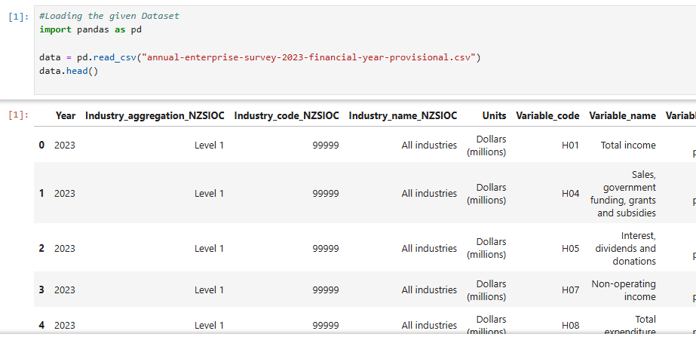

**Question 1: Printing Rows of the Data**

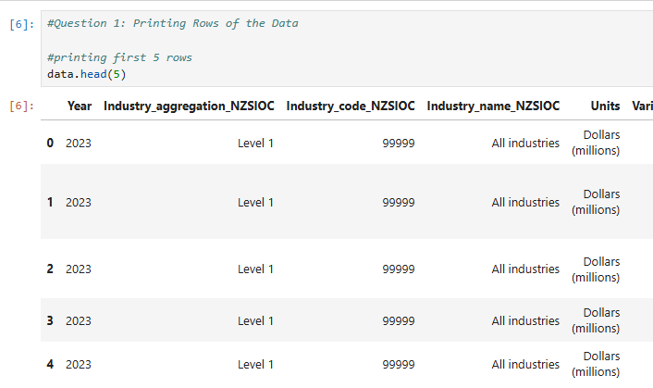

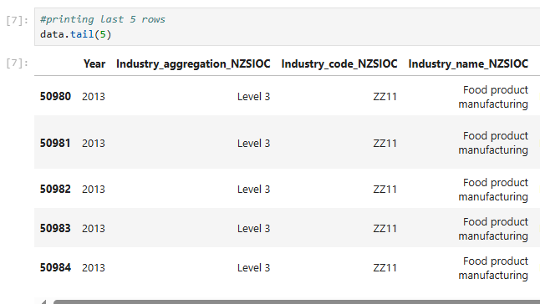

**Question 2: Printing the column names of the DataFrame**

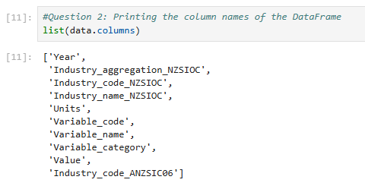

**Question 3: Summary of Data Frame**

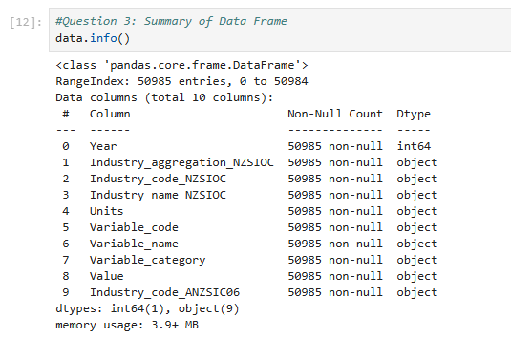

**Question 4: Descriptive Statistical Measures of a DataFrame**

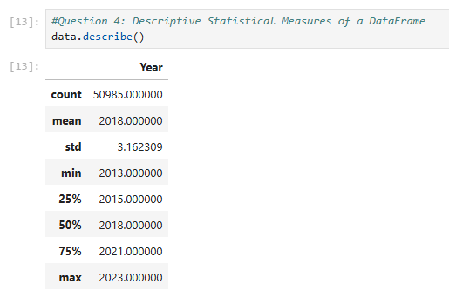

**Question 5: Missing Data Handling**

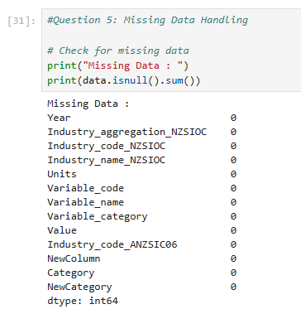

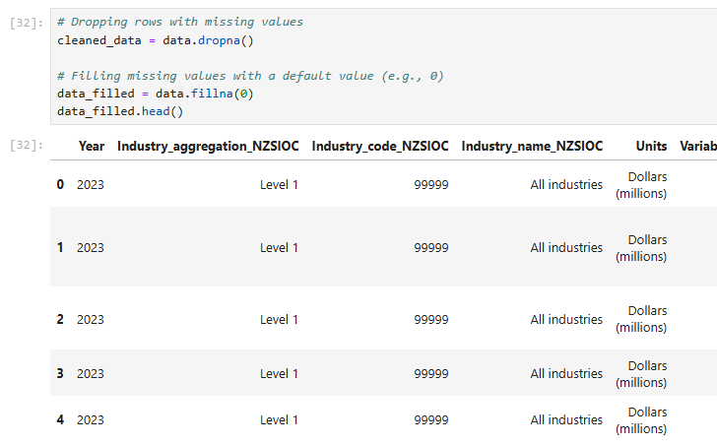

**Question 6: Sorting DataFrame values**

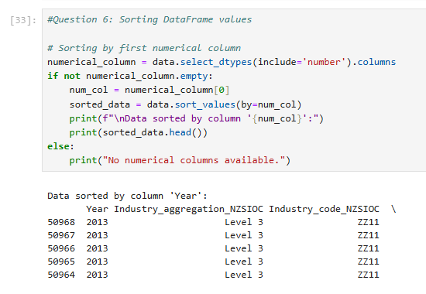

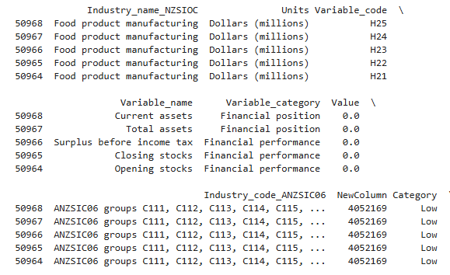

**Question 7: Apply Function**

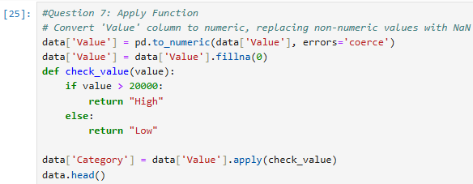

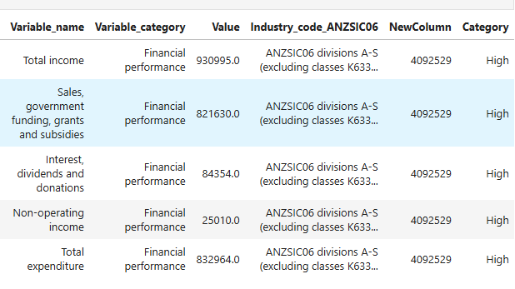

**Question 8: By using the lambda operator**

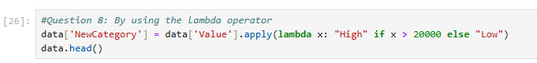

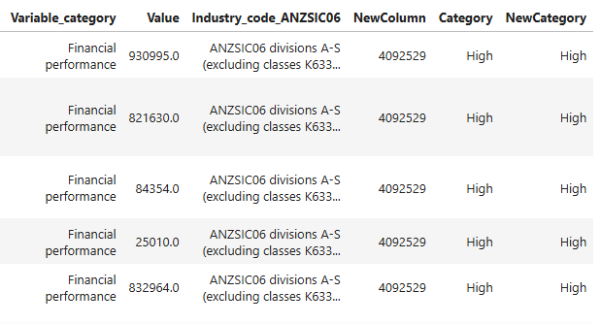

**Question 9: Visualizing DataFrame**

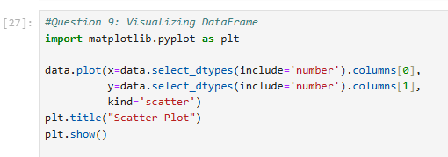

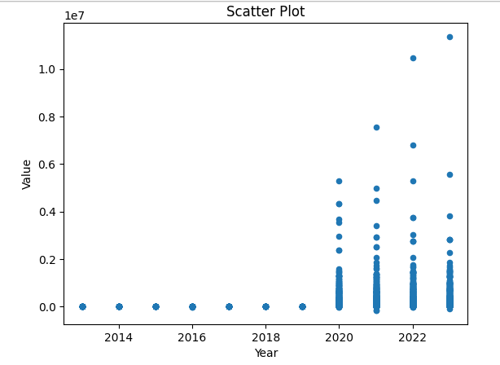

**Question 10: What is the number of columns in the dataset?**

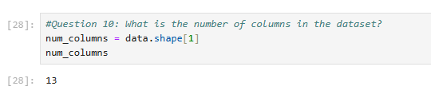

**Question 11:  How is the dataset indexed?**

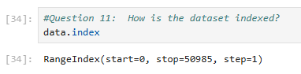

**--Thank You!**